﻿
Ship Consent Order (11) – This is already supported in AH - Presented as reference only https://cvs.quantummetric.com/#/replay/4503606675248078?globalFilter=c3903f231211fbf2&teamID=09399fee-5a37-4f6b-8b46-f59183245759&sessionTs=1736364958

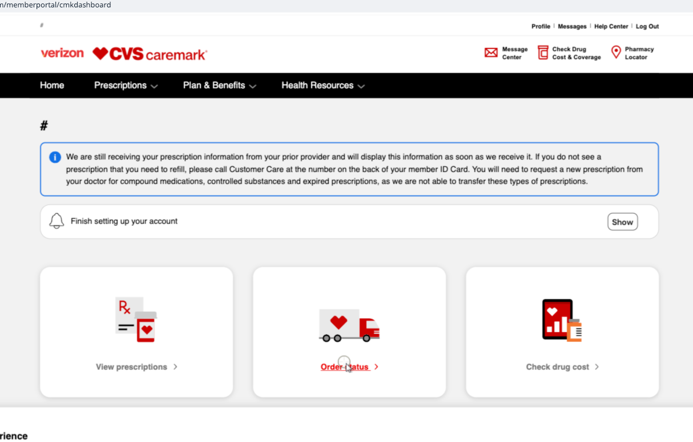

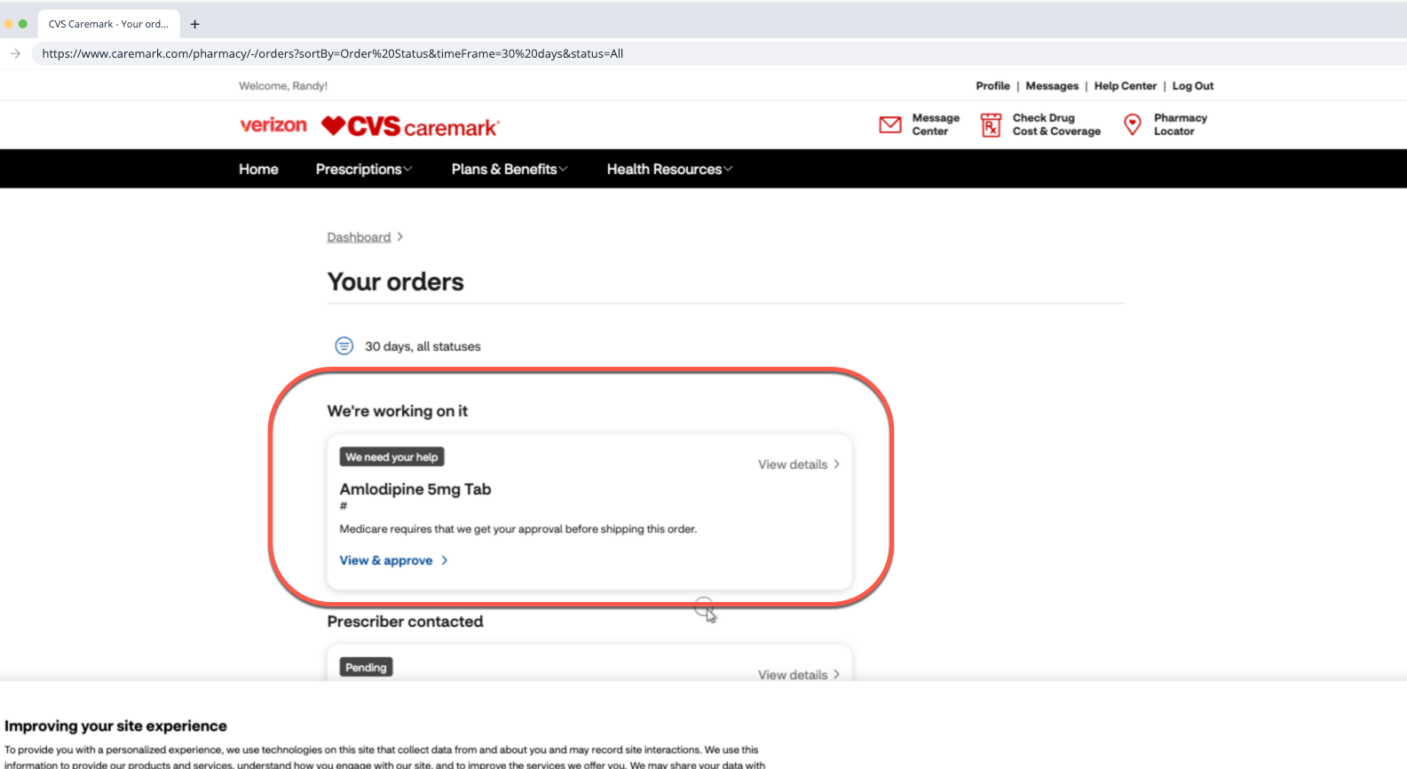

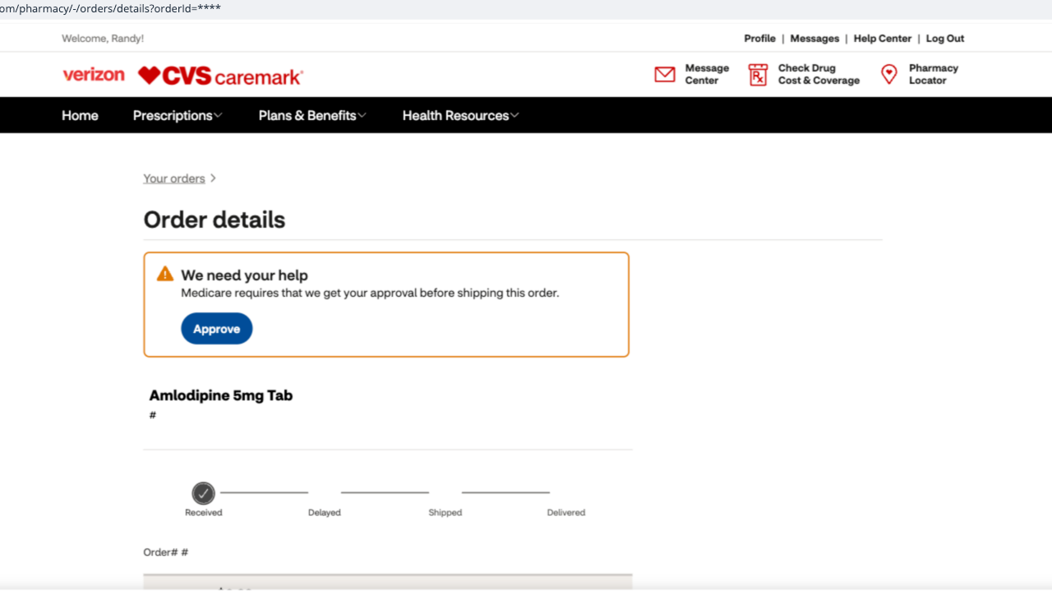

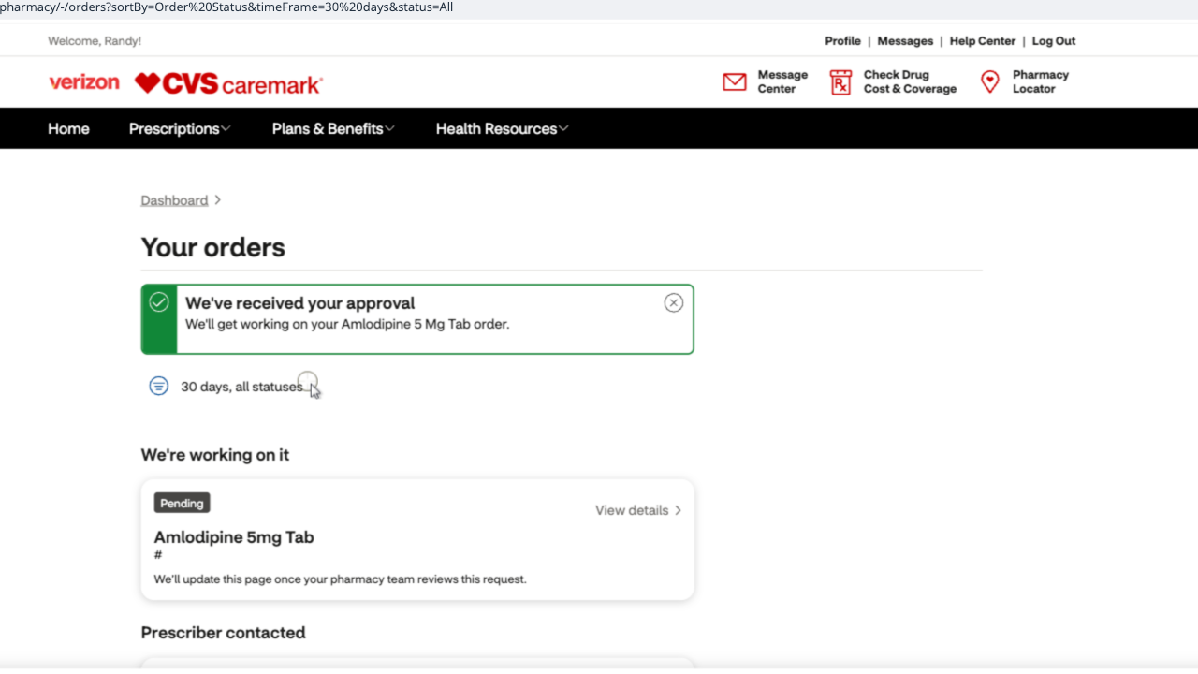

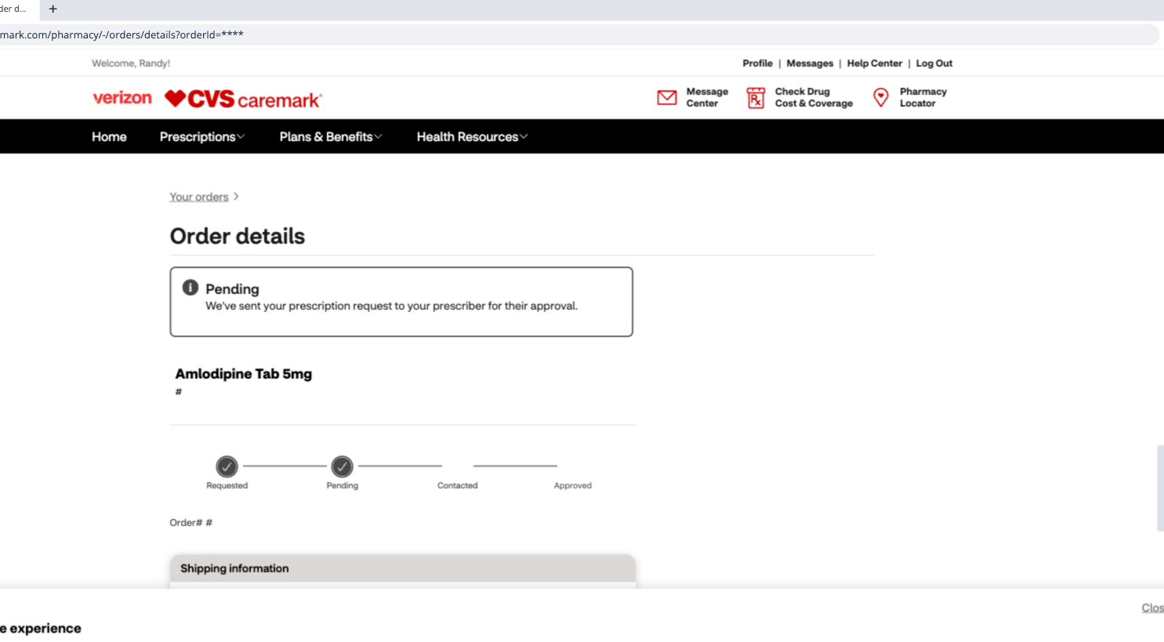

High Cost/Maximum Limit of plan/Generic (51,52,53) https://cvs.quantummetric.com/#/replay/4503606674301192?globalFilter=c3903f231211fbf2&teamID=09399fee-5a37-4f6b-8b46-f59183245759&sessionTs=1736363894

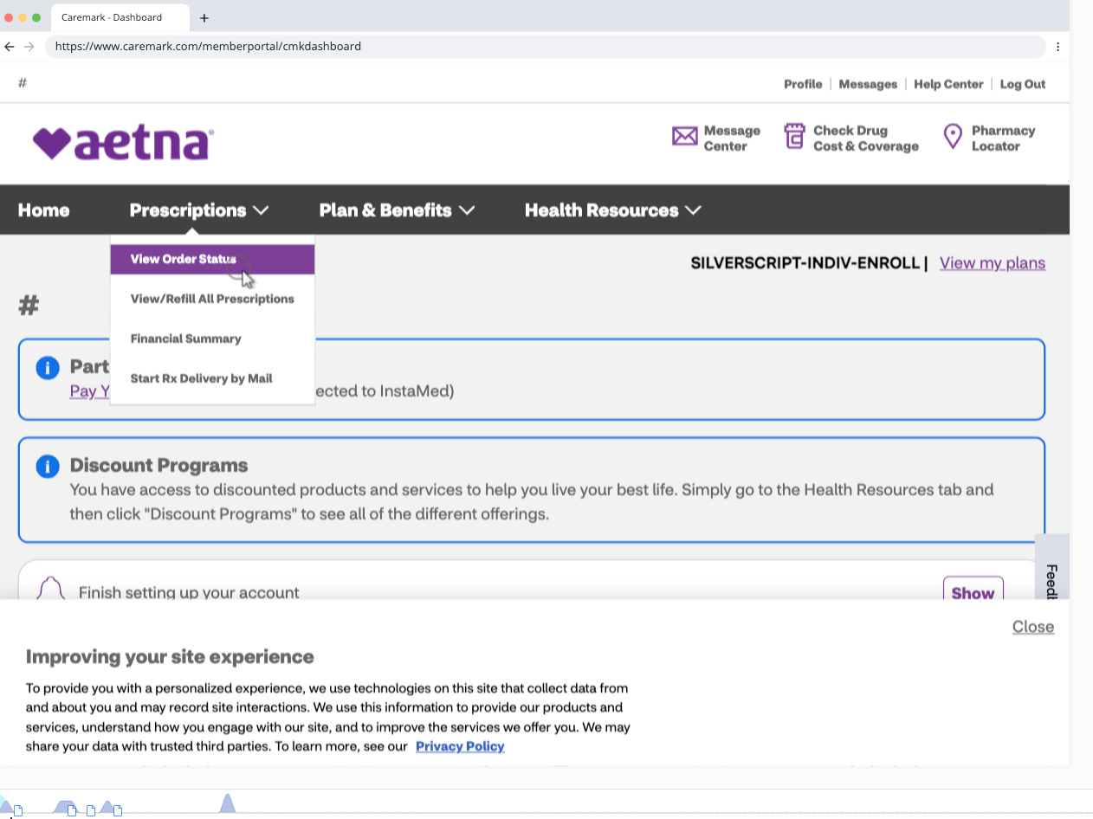

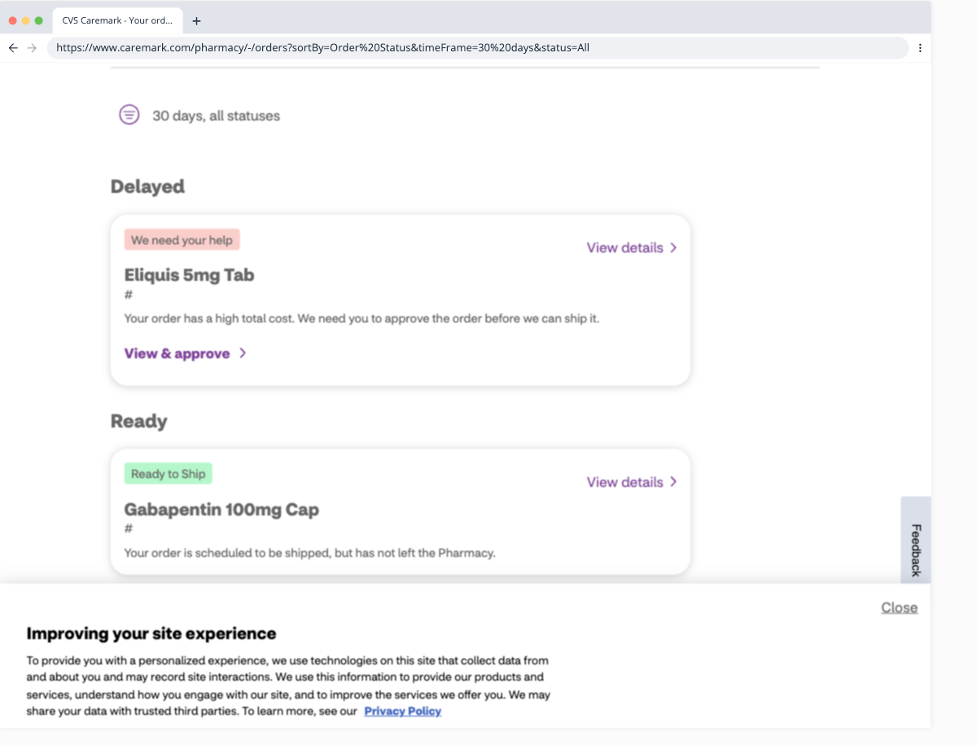

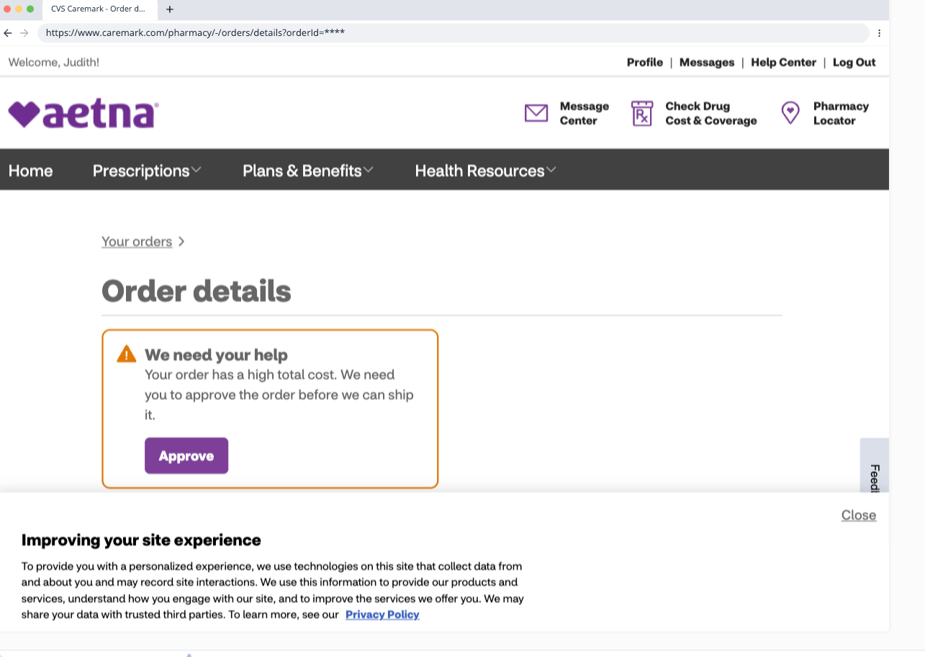

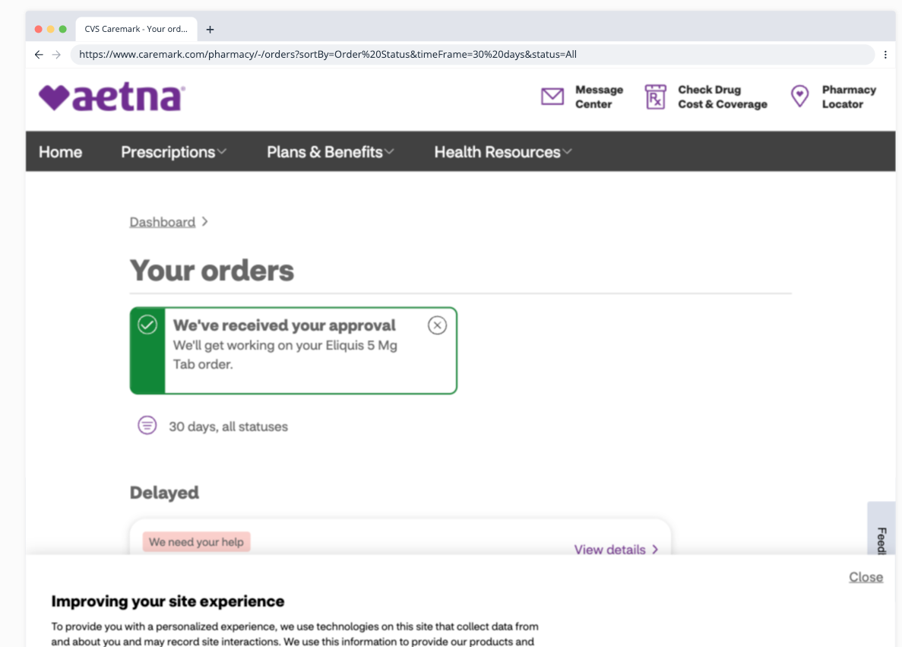

Payment Hold (13) - https://cvs.quantummetric.com/#/replay/4503606673181520?globalFilter=7bbaa34c04c6b987&teamID=09399fee-5a37-4f6b-8b46-f59183245759&sessionTs=1736362603

